**SMART AGRICULTURE SYSTEM BASED ON IOT**

**PROJECT REPORT**

**INTRODUCTION**

**A.OVERVIEW**

Smart Agriculture is a way through which farmer can have effortless farming techniques. In this project, the farmer can operate the motor without visiting the farm-land. This project is built using IBM cloud platform, Node-red and Watson IOT sensor. Using this project farmers can ON/OFF the motor without visiting the farm-land based on the temperature and moisture content.

**B.PURPOSE**

* Smart agriculture System based on IOT can soil moisture and climate conditions to grow and yield a good crop.
* The farmer can also get the real time weather forecasting data by using external platforms like Open Weather API.
* Farmer is provided a mobile app using which he can monitor the temperature, humidity and soil moisture parameters along with weather forecasting details.
* Based on all the parameters he can water his crop by controlling the motors using the mobile application.
* Even if the farmer is not present near his crop he can water his crop by controlling the motors using the mobile application from anywhere.

Here we are using the Online IOT simulator for getting the Temperature, Humidity and Soil Moisture values.

**LITERATURE SURVEY**

**A.EXISTING PROBLEM**

The main problem for farmers is that they should visit the farm daily and water all the crops. Visiting the farm which is so far and watering daily is waste of time and energy. To save the time and energy of the farmers we designed this project.

Problems of a farmer are mainly infrastructural and economic. The biggest hurdle to all this is the absence of technological resources and education.

**B.PROPOSED SOLUTION**

To overcome the above stated problem, to reduce the time and energy, the solution is Smart Agriculture System.

Smart agriculture System based on IOT, is a project which helps the farmers to save their time and energy. In this project, we developed a web application which has motor operating commands through which the farmer can operate the motor present in the farm without visiting it. The web application has options to ON/OFF the motor from the place they are.

This application is designed using IBM cloud platform, Node-red platform and Watson IOT Simulator. The motor can be switched On/Off based on the soil temperature, humidity and temperature. All these parameters are recorded in this application time-to-time. This application helps the farmers to reduce their efforts.

**THEORITICAL ANALYSIS**

**A.BLOCK DIAGRAM**

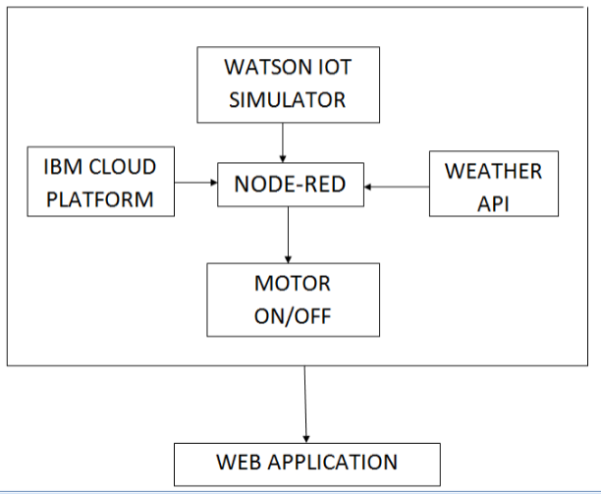

**B.HARDWARE/SOFWARE DESIGNING**

**PROJECT REQUIREMENTS:**

* IBM cloud Platform
* Python IDLE
* Watson IOT Simulator
* Node-Red service

**PROCEDURE:**

Create an account in IBM cloud platform. Search for IOT platform (Internet Of Things platform) in catalog and create a resource in it then, a platform is created.

Create device and note all the device credentials. Now open the Watson IOT platform (IOT sensor) and apply all the device credentials in it. The device will be connected with all the parameters like temperature, object temperature and humidity. The device and the sensor platform are connected.

Install the Node-Red platform locally in your system. Run the command node-red and open the link in new tab, it will be redirected to the node-red flow page. Create the flow with the device created on IBM IOT platform and all the required options like motor ON and motor OFF. Weather API is open source platform where the weather details of a particular region are noted. This Weather API is integrated in the node-red platform. A web application is created with the interface of IBM IOT platform and Node-red. The web application is created with all the data parameters and motor buttons.

Install the python IDLE in your system and write the code with the noted device credentials, motor commands and run the code. The commands given in the web application are viewed in python idle platform (MOTOR ON/MOTOR OFF).

**EXPERIMENTAL INVESTIGATION**

In this project we used the python code to get the required output. Whenever the button in the web application is pressed, the received command is display on the screen. For example, when the command motor on is pressed in the web application, “Motor on is received” is displayed. Similarly, when motor off command is given, “Motor off is received” is displayed. Thus, all the given commands work according to the input.

**FLOWCHART**

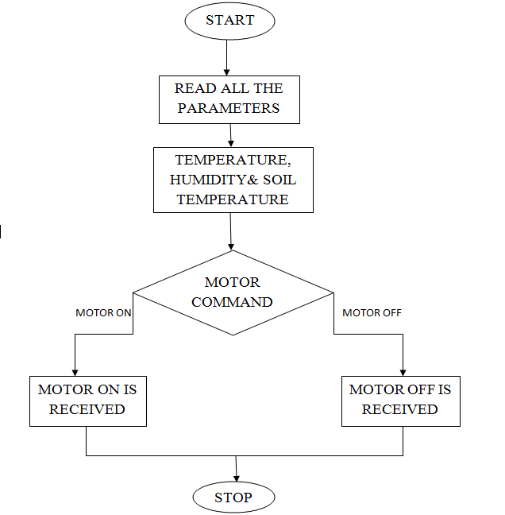

**RESULT**

When the command motor on is pressed in the web application, “Motor on is received” is displayed. Similarly, when motor off command is given, “Motor off is received” is displayed. Thus, all the given commands work according to the input.

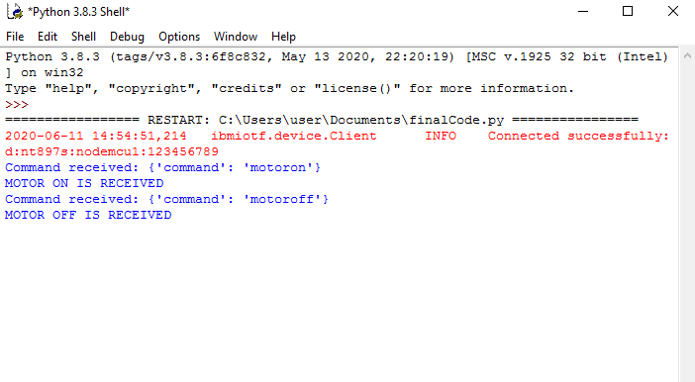

**ADVANTAGES AND DISADVANTAGES**

The main advantage of this project is it measures all the required parameters like Soil-Temperature, Temperature of the surrounding region using weather API and Humidity which helps the farmers whether to on/off the motor. A farmer can analysis the parameters and decide to on/off the motor. They can on/off it only with on button without visiting the farm. This helps them to reduce their effort and time to visit their land.

The disadvantage is the farmers now-a-days don’t have knowledge about the technology. To use this device they need to have minimum knowledge of operation a mobile application. They should be educated to use these applications. Thus, before implementing this device the farmers must be educated a little so that they can use this application without depending on others.

**APPLICATIONS**

Smart agriculture system based on IOT is a project which helps the farmers to reduce their efforts of visiting the farms daily and watering them. This application is designed mainly to help the farmers. Motor operations are done from anyplace based on temperature, humidity and soil temperature.

**CONCLUSION**

Therefore, the efforts of the farmers considered and designed to measure all the parameters. Making effortless farming techniques is the main aim of this project. This may not totally reduce their efforts but it mostly reduces them.

**FUTURE SCOPE**

* By maintaining various sensors information on cloud, user can access or control over his farm activities.
* Extensible feature of sensors we can add as per crop specific need.
* We can add motion sensors for monitoring behavior of animals.

**BIBILOGRAPHY**

<https://www.researchgate.net/publication/313804002_Smart_farming_IoT_based_smart_sensors_agriculture_stick_for_live_temperature_and_moisture_monitoring_using_Arduino_cloud_computing_solar_technology>